**Architecture**

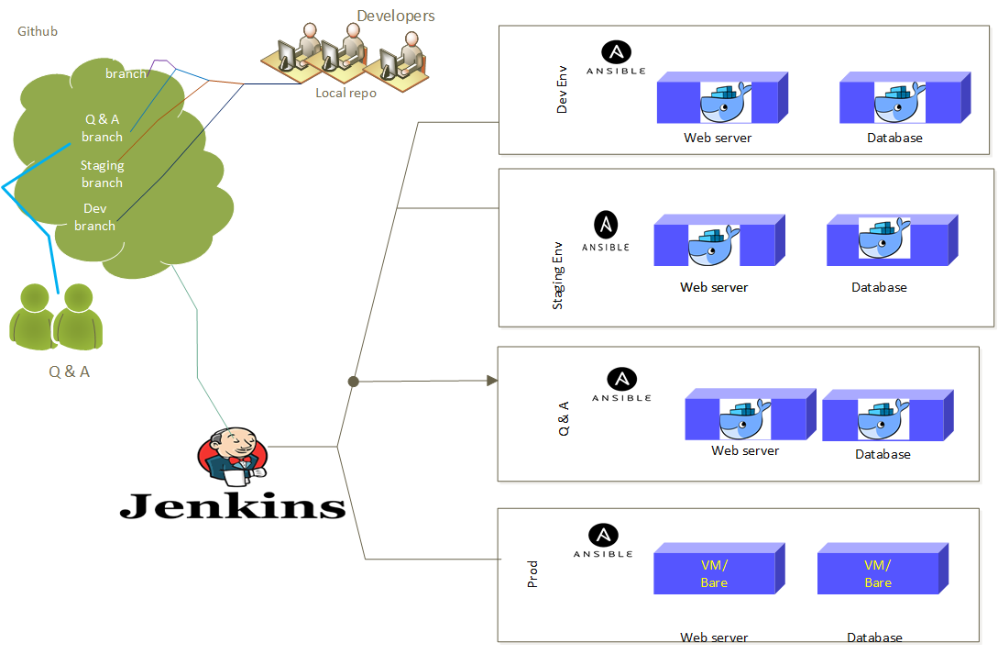

**Project overview and tools used.**

The project is deployment of ecommerce business, will writing the code and creating the backend for business using mysql. We will be using Devops for deployment and manage the ecommerce business. Devops will help to manage the code version, platform deployment, code deployment, testing, perform configuration management in prod env.

**Editor** - We will be writing the web development code up to some extent in sublime editor on local machine. All website code php, yaml, etc will write using sublime.

**Git** - We will be using git to maintain the code version and will use github for collaborating and maintaining the multiple braches. Will see how git help to maintain code version in development and deployment. All code website code will store on git hub and all developer can do the push and pull to their respective branches. Project Lead | Project manager comment the developer work to master/prod branch.

**Vagrant** - We will be creating the infrastructure configuration and VM deployment using vagrant, will code for infrastructure in ruby and perform VM deployment using virtual box (testing) and KVM (prod).

We will be installing the OS and software using vagrant cloud. Vagrant help to store the infrastructure configuration as code, like RAM, CPU, HDD size can be manager using ruby in vagrant.

**Docker container** – We be using the docker to create multiple environment like dev, staging, Q & A. Will use docker to create the platform. We will select the appropriate OS, Tools and create the image and same image will be used to create the container. Container help us to provide agile and portable platform for our development. In docker will user YAML to write script for environment preparation and creation

**Ansible** - We will use ansible to automate the configuration management. Will do the deployment of logical deployment like Apache server, database server using ansible. Will do the change management in configuration using ansible. Our website will be hosted on apache and database server will be mysql so will use ansible for complete web & database server deployment.

**Jenkins**- We will use Jenkins for integration multiple tools and system. In our project will integrate Jenkins with Git, docker and ansible to achieve complete automation and avoid human error.